Mary Williams Elementary School
3100 Panther Pride Drive
Dumfries, VA 22026
(703) 445-8376

12/3/2021
How to Access Programs in CLEVER from Home
- Open a web browser. The preferred browser is Google Chrome.
- Type office365.pwcs.edu in the address bar
- Log in with your Office 365 username and password
  - For example: username BruceTY22@pwcs-edu.org
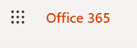
  - For example: password 123Nov456
- Click on the waffle in the upper left hand corner.

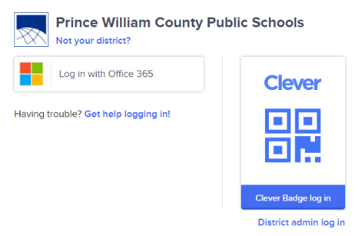
- Look for Clever and click on it. If you don’t see Clever, you may need to click on All apps, then scroll down to the bottom to see Clever.
- A white box will come up that looks like this.

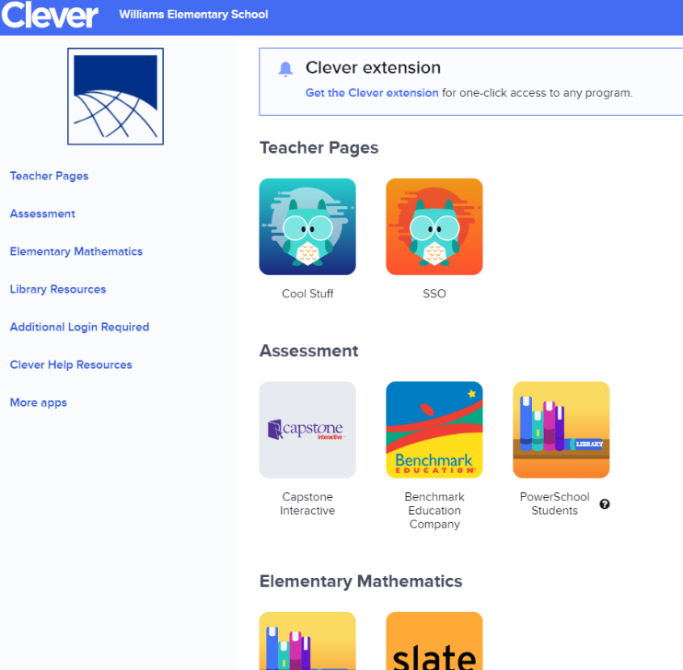
- Click on Log in with Office 365. It will take you to the Clever Page that looks like this.

- Scroll down to see IXL (math and language arts app for K-5), MyOn (reading app for K-5), and Wixie (writing, drawing, recording app for 1-5) . There should be no additional log in required to get into these apps. You can also get into Typing.com, Code.org, and Worldbook Online without an additional log in.

